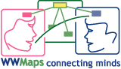 | WWMAPS Project  how to participate to WWMAPS | Ver. 01 –25/09/05  RP

1. What it is compulsory to forward
To be registered and filed in the data base you need to specify:

1. College/School name, town, nation and college/school web address if there is one (even single students can be registered and participate)
2. Who creates the concept maps (also dealing with different subjects) cooperating with other students in teams. For instance:
Chi sono i soggetti che dovranno costruire le mappe concettuali (anche in settori differenti): associandosi ad altri studenti in team di cooperazione. Per esempio:
- The single student (whose name must be specified)
- A group of students (this group must have its own name. its members can belong to different classes or come from different schools)
- The whole class (its name must be specified)
3. The age range of those who are interested in the co-operation
4. Any favoured educational content, topic and area to be developed in co-operation with other students
5. The students’ mother tongue and the L2 chosen between Spanish and English, to communicate with other partners. The L2 can be used either by students or adults (school teachers/tutor from the wwmaps staff).
6. The tutor’s, teacher’s or parent’s name, who would take part in the WWMaps Community, along with their email address. Broad contents and flexibility are recommended in case you should modify/redefine the educational fields, or find a new partner interested in it.
Following a mock table with some fields. Each different “field” is in accordance to the Italian Primary School Curricula (ambito). Nevertheless the arrangement of the subjects is arbitrary.

Field | Area | CMap Topics samples
Anthropological | Geographical-Historical | Physical, social, political, economical Geography. Ages, History of populations and races. Geographic discoveries, Migrations, Reigns/Empires, Revolutions, Civilization.
Anthropological | Social Science | Human Rights; Ethics; Democratic Social Coexistence; social, political, work organization. Ethos and Values.
Anthropological | Cultural Expressions | Literature, graphic arts, crafts, music, cinema, sports…
Anthropological | Religion | Religious Orders, Believes and Rites, The Holy Scriptures, Religions Hist., Religions coexistence, Relationship between Faith and Science
Anthropological | Events – Topics | Natural Events; Social and Political Events; daily life
Logical-mathematical scientific | Environmental Education | Resources; Air, Water, Ground Pollution, Bio diversity, Waste, recycling etc.
Logical-mathematical scientific | Science Experimental Inquiring | Projecting Experiments, reports of research and revision of inherent concepts
Logical-mathematical scientific | Natural Science | Disciplines (Physic, Chemistry, Biology, Astronomy etc.)
Logical-mathematical scientific | Technology | Technology Arts, Computer technology, work projecting and realization
Logical-mathematical scientific | Mathematics | Set Theory, Movement, Geometry, Logic, Arithmetic, Measures, Data elaboration, Problems, Algebra, Statistics…

2. Editing of your partner’s MeToo map primary data

It takes no longer than 10 minutes to “…on cmap” register to the WWMaps project.

- Launch the cmap tools program and from the window Views open first “Shared Cmaps in Places” and then IHMC Public Cmaps (2) server folder. Look for 2WMAPS folder, on the top of the list. The folder contains the shared resources of the WWMaps Community teams.
- From 2WMAPS folder double click on METOO map to open it, and follow the given instructions:
- Select the data that will have a light purple background (for the English language)
- select Modify and choose Copy
- select Modify and choose Paste. A copy of the box will be pasted somewhere at random.
- Move the box somewhere else in the screen, no matter if it is superposed to other boxes.
- Fill it with the required data. You can also overwrite the words Name, City, Country, Tutor, email, website.
- select File and choose Save.

This updated map is at disposal from www.2wmaps.com site at this Internet address internet.
The pictures sequence shows the above mentioned steps.

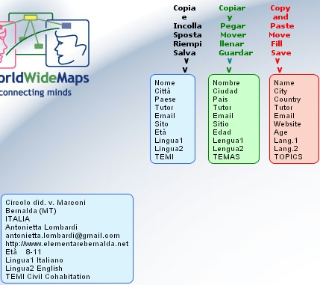

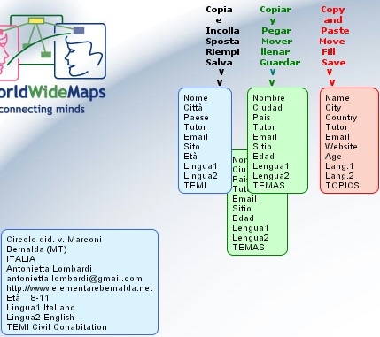

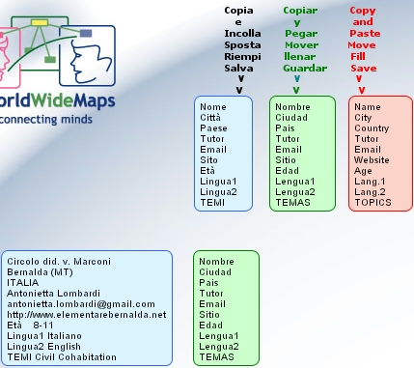

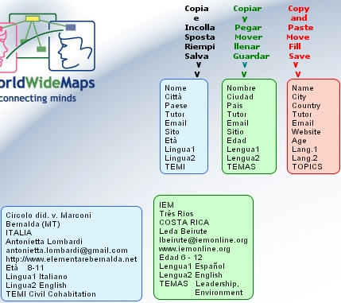

3. What to do after the registration

If your data are on line on the MeToo map you are eligible to participate in the WWMaps project. You can also choose a partner, or be chosen.
The Community must be informed about any new entry by sending an email to info@2wmaps.com, where further details or information can be added (i.e. introduce your class, yourself, your school).
The WWMaps staff add the co-ordinators’ email address in the WWMaps mailing list, community@2wmaps.com. From this address any information would be forwarded to all the participants and screened by the moderators. It is possible to write to the Community even if you are not registered.
Finally you have to register to the Forum in www.2wmaps.com/bbforum, where you can read FAQs and submit questions.

4. Constitution of co-operation Teams

The community activities and www.2wmaps site browsing, promote both the co-operation among teachers from different schools in the world, cultural exchanges, within creation of Concept Maps.
When two or more partners co-operate, a tutor from the WWMaps staff would supervise the whole team-project.
Therefore it is important to be as much informed as possible. For any detail, visit the project web site at this document.

Cooperation Team: it is a closed group of students from different countries, supervised by their teachers/tutors. They work together to create Concept Maps over different themes. The team co-ordination is within each team and it is supported by the 2wmaps.com/bbforum for the co-ordinators, and by the CmapTools environment for the students. CmapTools allows different forms of collaboration, such as the Discussion Threads (similar to topic forum). Each team is given a tutor from the wwmaps.com staff. Every team (with the assigned tutor included) creates a team folder in the 2WMAPS main folder, placed in the Cmap Server: IHMC Public Cmaps (2). This main folder contains further sub-folders of the co-operative units, where concept maps or knowledge models are created.
Examples: the “IEM-Ber” team is formed by IEM school of Tres Rios (Costa Rica) twinned with Bernalda Primary School (Italy), in order to co-operate over important contents such as citizenship and human rights. Instead, the “IEM-A.Luis” team formed by IEM school (Costa Rica) and San Luis of Manizales College(Colombia), deals with the origin of the American populations.

Co-operation Unit: within the teams there can be different units relating to various contents. Each unit or sub-team must deal with one single map or knowledge model referred to a single content, and must use a specific folder which is placed in the team folder. Concept Maps dealing with different aspects of the same subject are part of the same co-operation unit and all together form a Knowledge Model.
Examples: the “IEM-Ber” team can form a co-operation unit with Primary S. students at their 4^ grade from both the twinned schools, and while this unit would deal with the citizenship rights, another unit formed by kids at 5^ year would create a knowledge model about the ONU rights.
Therefore the co-operating Team would focus on the partners of the partnership, whereas the co-operation unit is defined by the content which will be developed and shared.
The Team Units and the relative contents are defined by the co-ordination of the belonging Team. Team and Unit coincide if the partnership is referred to a single content.

